FL10. Offline. Lesson 2. CSS Optimization

**DEADLINE:** 19/03/2019

## FOLDER STRUCTURE

Homework_02/

├─ styles/

├─ bootstrap.min.css

├─ font-awesome.min.css

├─ critical-styles.css

└─ styles.css

├─ img/

├─ fonts/

├─ js/

├─ jquery.js

├─ bootstrap.min.js

├─ jquery.parallax.js

├─ smoothscroll.js

├─ lazyload.min.js

├─ loadCSS.js

└─ custom.js

└─ index.html

## TASK

Make front-end optimization for FLX page including:

* Minify and Concatenate CSS in one file (Use online tool [Shrinker](http://www.shrinker.ch/))
* Implement asynchronous load of CSS and JS:
  + For JS use ‘defer’ or ‘async’ attributes for ‘script’ tag
  + For CSS use “loadCSS.js” plugin ([See documentation](https://github.com/filamentgroup/loadCSS#manual-css-loading-with-loadcss))
* Add “Critical CSS” to provide quick first meaningful paint:
  + Copy styles from “critical-styles.css”
  + Paste them in <head> as inline styles using tag <style>
* Create smaller version of all images for mobile devices. Use ‘srcset’ attribute to show proper image depending on screen size.
* Implement lazy load of images using “lazyload” plugin ([lazyload.js](https://github.com/verlok/lazyload))

**Setup:**

- Install Node.js and NPM (skip this step if already installed)  
- Install local web server running `npm install -g http-server` (use `sudo` in case of permission errors)

- Open project folder in terminal/command line and run `http-server` command

- You can find your server running on ‘http://127.0.0.1:8080’

- All CSS and JS libraries can be found already downloaded and ready to use in project folders

- Use ‘Network’ tab in browser Developer Tools to check performance improvements

- **Mandatory**: ‘Disable cache’ flag should be checked in ‘Network’ tab to prevent assets from caching

## RESTRICTIONS

* Vendor libraries source files shouldn't be touched at all
* No need to use any of build systems (grunt, gulp, webpack)

## BEFORE SUBMIT

* Check ‘Network’ tab to be sure that all performance improvements work properly
* Using Chrome, open ‘Audit’ tab in Developer tools menu. Run ‘Audit’. Score should be not less than 70 (not mandatory point). Use settings:
  + Device – Desktop
  + Audits – Performance
  + Throttling – Simulated Fast 3G, 4x CPU Slowdown

## USEFUL LINKS

* [https://www.npmjs.com/package/http-server](—%09https:/www.npmjs.com/package/http-server)
* <http://www.shrinker.ch/>
* [https://github.com/verlok/lazyload#lazy-image](—%09https:/github.com/verlok/lazyload#lazy-image)

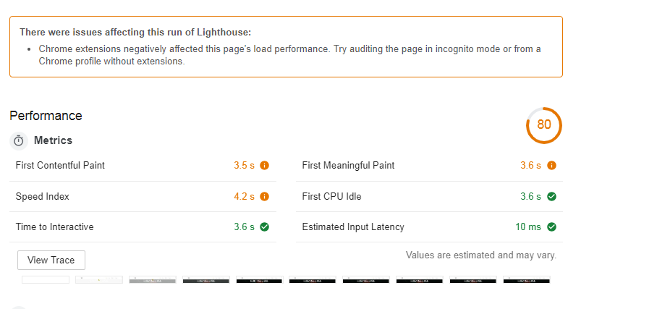

**940 KB transatrred DOMContentLoaded: 310 ms 410 500**